Boland, Doug (from Council of Heads of Australian Herbariums website)
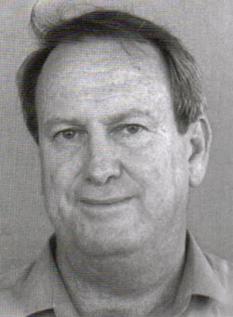

Born 7 May 1947, died 31 May 2001 in Canberra ACT.
He was born in Inverell, NSW, son of John and Vida Boland and brother of Greg and Mary-Lynne. The family moved to Nambucca Heads in 1957 and Doug attended the Macksville High School.
He gained a Commonwealth Forestry Scholarship in 1965 and this encouraged his tertiary studies at the University of New England after which he completed his BSc (Forestry), graduated 1968. He was senior editor and co-author of some major books - Forest Trees of Australia, Eucalyptus Seed and Eucalyptus Leaf Oils have become standard texts.
Awarded the Institute of Foresters of Australia's Hedges Prize in 1983 for his paper Selection of Australian trees other than eucalypts for trials as fuelwood species in developing countries.
In 1984, Doug travelled to Brazil, Spain and South Africa on a Churchill Fellowship to examine the commercial use of Australian eucalypts.
Appointed to the International Centre for Research in Agroforestry in Nairobi for four years from 1991, where he earned the Centre's Certificate of Merit for Research Achievement.
He designed and conducted rapid surveys to examine priorities for the use and conservation of forest genetic resources in 30 village communities in Fiji, Tonga, Samoa, Vanuatu and the Solomon Island.
To the CSIRO Australian Tree Seed Centre he introduced the concept of tree domestication a process through which a species is brought from the wild into cultivation and productive.
He is survived by his wife Carol and children Mark, Lara and Chantelle.
STEPHEN MIDGLEY

